SAINT FERDINAND CHURCH
RELIGIOUS EDUCATION PROGRAM
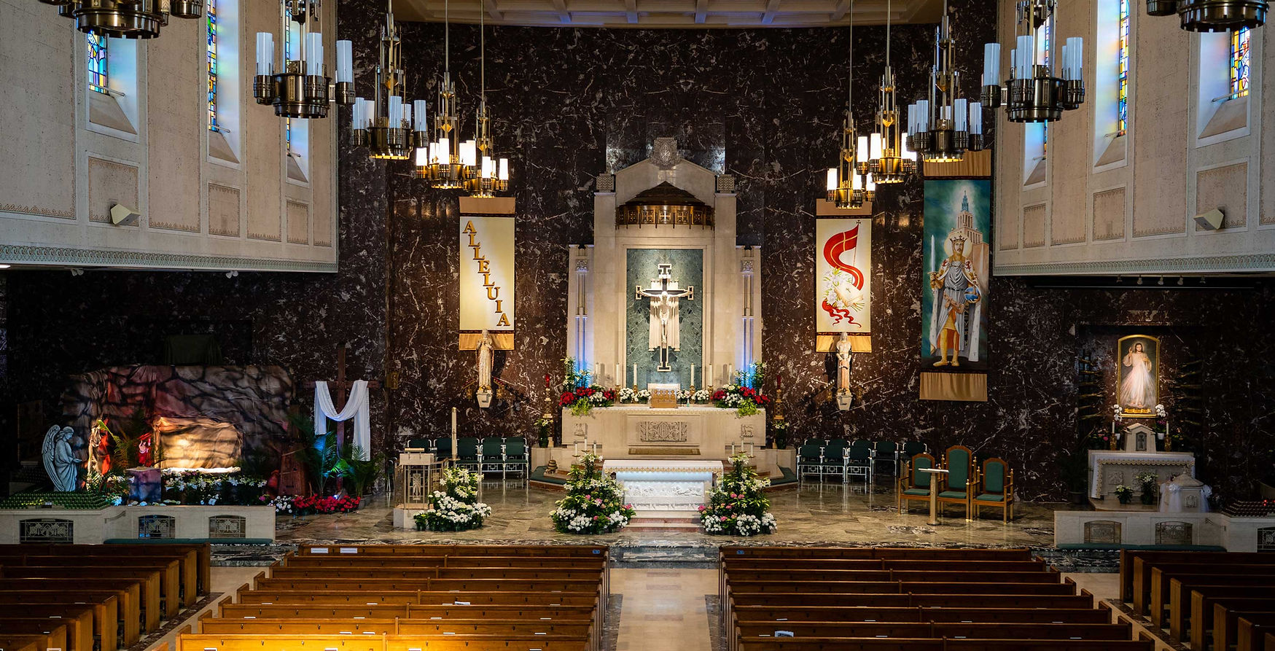

DITO’S CLASS | AGNES’S CLASS | BARBARA’S CLASS | CAROLINA’S CLASS
2ND YEAR OFCOMMUNION | 2ND YEAR COMMUNION | 1ST YEAR COMMUNION | 2ND YEAR COMMUNION
MARITA’S CLASS | ELIZABETH’S CLASS | EMMA’S & FLOR CLASS | WILL’S CLASS
1ST YEAR OF CONFIRMATION | 2ND YEAR OF CONFIRMATION | 1ST YEAR COMMUNION | RCIA
MAP OF WHERE CHILDREN WILL SIT DURING MASS. PLEASE BE AWARE ABOUT YOUR TEACHER NAME AND THE PROGRAM.
REMIND: NO PAJAMAS, SHORTS, HATS, CAPS, SHOWER SANDALS AirPods, RIPPED JEANS, CROP TOP ALLOWED DURING MASS

