**Are you interested in becoming Catholic?**

**O learning more about Catholic Faith,**

**Are you an Adult and need a Sacrament?**

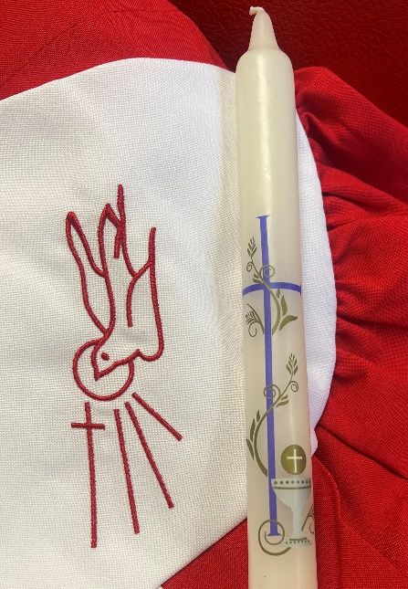

**OCIA**

Order of Christian Initiation of Adults

* Want to be a Catholic
* Want to be Baptize, Reconciliation, Communion, Confirmation

**Come and see- Every Sunday from 9:30 AM to 11:30 AM**

Class starting on September 15, 2024

**For more info contact:**

**Religious Education Office**

Sunday from 8:00 AM to 2:00 PM

Tuesday & Thursday 9:00 AM to 3:00 PM and 5:00 PM to 7:00 PM

Wednesday and Friday from 9:00 AM to 3:00 PM

Contact: Xochilt Aleman, DRE Tel: 773-622-3022 ext. 365 Cell: text or call at: 872-216 -0434

[xaleman@saintferdinand.or](mailto:xaleman@saintferdinand.or)g

(Hablo Español)