Saint Ferdinand Church
5900 W. Barry Il 60634
Tel. 773-622-5900
Religious Education Office 773-622-3022 ext.365
Religious Education Program

Rules and Regulation Handbook
O
C
I
A
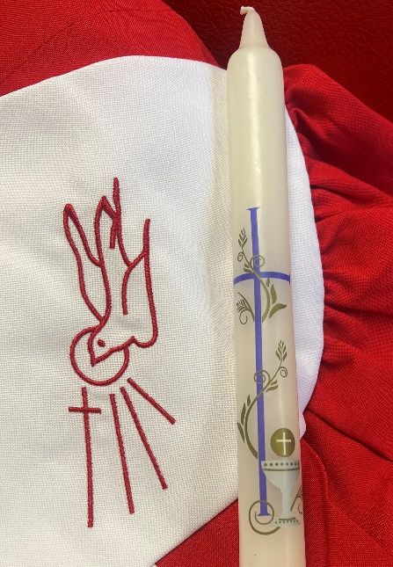

“The first and most important place through which faith passes is the home, through the calm and daily example of parents who love the lord and trust in his word”
Pope Francis
Dear Families:
It is a true pleasure to cordially welcome you to our 2023-2024 Fait Formation Program. With trust in the Lord we being this new year of catechesis with the convictions that He is the only one who can touch the hearts of his children and yours to make them experiences his love and mercy through his Word, the reception of the sacraments and community life.
For our part, the entire team of catechists, our priests and volunteers, will put all the efforts into helping you in this mission, offering our time and best efforts to transmit the fait to you children. To carry out this mission it is necessary that we can have a very active participation in our catechism program. Therefore, we remand you:

Classes: all classes are on Sunday from 9:30 to 11:30 fallow by the Mass at 11:30 to 12:30. No cell phones are allowed during class or mass, with the exemption of using for class purpose and under teacher supervise. Parents must sign in on the classroom and sign out at the end of mass. Students cannot leave the church without sign out.

Mass Students must attend Holy Mass at 11:30 A.M together with their class group. Parents must sit next to the child. Only three (3) unexcused absences are allowed per catechetical year. Students must be picked up and sign out at the church. Hygiene and modesty are necessary to attend mass. Children will participate actively during assembly (NO pajamas, ripped pants, earpads, cell phone, caps, hats, or shower sandals are allowed). Be sure to prioritizing Mass attendance even on days when we do not meet to class.

Homework Parents are responsible for verifying completion of homework assigned to the students. Check your child folder every week, news and important information will send it home. In the event of an absence, parents are required to contact the catechist to find out what topic or lesson was covered in class, so that the lesson or activity may be completed before return to class.

Prayers Students will expect to learn:
K-2 grade (1st Year of Communion) Sign of the Cross, Our Father, Hail Mary, Glory be, genuflecting correctly by the present of the Holy Sacrament.
3-5 grade (2nd Year of communion) all above and Act of contrition, Creed, ten Commandments, 7 Sacraments.
5-7 grade (1st Year of confirmation) All above and Prayer of the Holy Spirit, spiritual works of mercy, the Beatitudes.
8-up (2nd Year of confirmation), All the above, and the five precepts of the church.
OCIA, All above Prayers.

Sacramental Preparation
Our program has two years consecutive preparation. During these two years, special events will be planned for children and parents. Please attend on time, participate, and ask your child/ children about their experience.

Sacraments Records
All student must provide Baptismal, Birth certificate, and reconciliation records at the time of register. If you can make copies we will be happy to make it for your convenience.
1 Child $180 2 Children $250 3 or more $320
Package Fees Reconciliation and
First Holy Communion $110
(add to 2nd year tuition) Confirmation $140

Tuition
Please be sure to cover the total amount of tuition by December 2023. Only 3 absents are allowed for a catechetical year after 3 absent you child will be automatically dropped from our program. After 3 absent of the students is not refund on tuition for any program. If you have issues paying in full, talk to the DRI or 773-622-5900 ext. 231. The Fee for package Included, Flowers for the church decoration, gift for offertory procession, Pictures package.

Holy Eucharist: Every Thursdays from 8:00 am to 7:00 pm, The Holy Eucharistt is expose on Church, We invited you to attend as a Family.

Attendance: we will meet for 28 sessions. Attendance is important. Attendance includes being active during mass as a family. Only three absences are allowed during the program. Be aware of the calendar year. If you child cannot attend please contact the Director of Religious education or your catechist please arrive on time, three tardiest count like one absent.

Catechist: Our teacher are volunteers they prepare their classes every week attending to “The echoes “Please support them, pray for them and offer a help through the coming year. Be sure you child is respectfully with the teacher during class and Mass.

Security Issues: In order to continue provide a secure environment the school is close at 11:20 AM. Children can not leave the Mass with out parent signature. Children cannot walk home alone.

Parents Participation: as a partnership we expect parents be respectfully and support teacher during this religious education year by, attending to parents meeting, support teacher decision and participate active in knowing the homework and practice the prayers with their child. Parents, students, DRE, teacher must read, understand and sign the agreement of, religious education rules good standard behavior and discipline.

Service Hours Confirmation and OCIA must do 40 hours of service, 20 each year.
Sponsor: It is the sponsor's privilege and responsibility to be a model. The sponsor must be a practicing Catholic who frequently receives the Holy sacrament. The sponsor can be male or female, should be sufficiently mature in their faith commitment, and must be fully initiated themselves (having Baptism, Confirmation, Eucharist, Marriage by the church if applicable). Please dress appropriately for the ceremony, women. No short dress or skirt and no necklines.

Pictures and DVD
We will take pictures of student’s activities for publication on St. Ferdinand website under the Religious Education section. Be sure to sign in the permission form. During the rite: parents, family members, and godparents cannot take pictures to respect the sanctity of the Mass. A professional photographer will be taking the photos, and a DVD will be available to purchase.

Religious Education Office Hours
September to May
Sunday from 9:00 AM to 11:10 AM
Tuesday & Thursday 9:00 AM to 3:00 PM and 5:00 PM to 7:00 PM
Wednesday and Friday from 9:00 AM to 3:00 PM
Contact: Xochilt Aleman, DRE Tel: 773-622-3022 ext. 365 Cell: text or call at: 872-216 -0434
xaleman@saintferdinand.org
(Hablo Español)

